Neptune Windows Server Installation Guide

1. First we need to copy Neptune source code to local server. Open CMD then CD to folder:

https://scontent.fmnl5-1.fna.fbcdn.net/v/t1.15752-9/87458045_503046067293008_1419438604874153984_n.png?_nc_cat=104&_nc_sid=b96e70&_nc_ohc=LCygSjvfIxQAX9gTc79&_nc_ht=scontent.fmnl5-1.fna&oh=d81669f1aca38652eb283d50267348e7&oe=5E9A2C54

Or if you have gitbash installed on your machine, you can go directly to that folder then right click: gitbash here, see screen shot below:

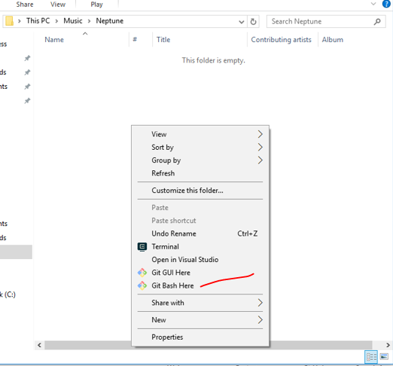

1. In the command line type: git clone <https://github.com/geffers12345/neptune.git> then hit Enter, see screenshot below:



1. To confirm that it was cloned, you will see this screen below:

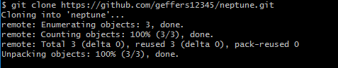

1. Open the folder https://scontent.fmnl5-1.fna.fbcdn.net/v/t1.15752-9/87458045_503046067293008_1419438604874153984_n.png?_nc_cat=104&_nc_sid=b96e70&_nc_ohc=LCygSjvfIxQAX9gTc79&_nc_ht=scontent.fmnl5-1.fna&oh=d81669f1aca38652eb283d50267348e7&oe=5E9A2C54 you will see the code has been copied.

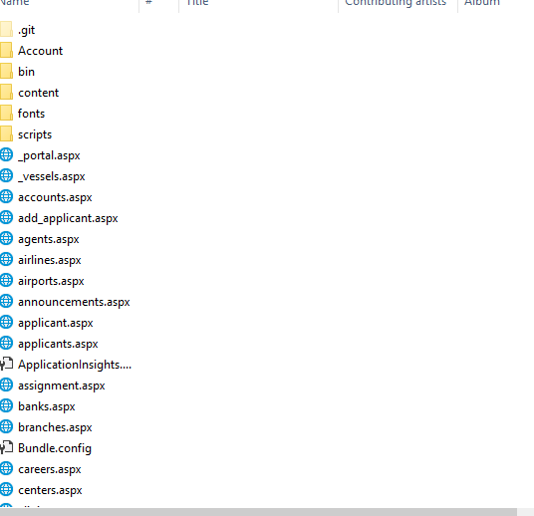

1. Follow this link for the next steps.

<https://www.guru99.com/deploying-website-iis.html?fbclid=IwAR2FGCcyFi_CVbDgBuu5BayQlQwvybsExafMTIUIi98cnpFVEgoTKJH5-S4>